**OPERATING SYSTEMS – CSE316**

**Assignment based on Multithreading and Page Fault**

**Student Name:** Rohith Thokala

**Student Registration ID –** 11813646

**Email Id –**  rohithkumar.1601@gmail.com

**Github –**

**Section –** K18GT

**Roll No – 56**

Code for Program Fibo Series

#include <stdio.h>

#include<unistd.h>

#include <pthread.h>

#include <stdlib.h>

pthread_t tid;

pthread_t tid2;

int fibo[1000];

int top=-1;

void *printFibo(void *vargp){

pthread_join(tid2,NULL);

sleep(1);

for(int i=0;i<=*(int*)vargp;i++)

{

printf("%d",fibo[i]);

printf(" ");

}

}

void *calcFibo(void *vargp){

int t1 = 0, t2 = 1, nextTerm = 0;

fibo[0]=t1;

fibo[1]=t2;

top=1;

int i=0;

while(i <= *(int *)vargp)

{

nextTerm = t1 + t2;

top++;

fibo[top]=nextTerm;

t1 = t2;

t2 = nextTerm;

i++;

}

}

int main()

{

int n;

printf("Chose a number to get Fibo series");

scanf("%d",&n);

pthread_create(&tid,NULL,printFibo,(void*)&n);

pthread_create(&tid2, NULL, calcFibo, (void*)&n);

pthread_join(tid, NULL);

exit(0);

}

Algorithm:

1.The algo collects the value from the user when entered .

2.In the next step the program creates a separate thread which generates Fibo series.

3. If the child process is created then the value is used inside a while loop and then the sequence is printed.

4- When the thread finishes execution,the parent thread will output the sequence series generated by the child thread.

Algo:

START

Procedure Fibonacci(n)

declare f0, f1, fib, loop

set f0 to 0

set f1 to 1

display f0, f1

for loop ← 1 to n

fib ← f0 + f1

f0 ← f1

f1 ← fib

display fib

end for

END

Test Cases:

Test Case 1 :

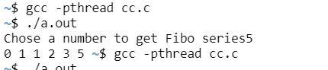

Test Case 2:

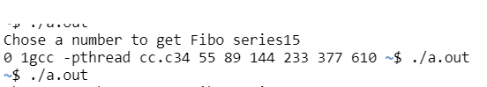

Test Case 3 :

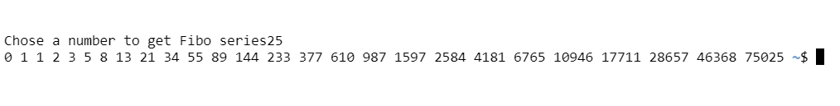

Test Case 4 :



Tested with 4 different values.

2.Code for Page Fault and Effiecient Access Time:

#include <stdio.h>

#include <stdlib.h>

double page_fault_rate();

void userInput(void);

double sp_fault_empty;

double sp_fault_modified;

double mat;

double tp_modified;

double eat;

double pageFaultRate;

double sp_fault_empty_ns;

double sp_fault_modified_ns;

double tp_modified_per;

void main(){

int swtch;

do{

printf("Select the required option \n");

printf("1.Find the PageFault Rate \n");

printf("2.Exit");

scanf("%d",&swtch);

switch(swtch){

case 1:userInput();break;

case 2:exit(0);

}

printf("\n\n");

}while(swtch<3);

}

void userInput(){

printf("\nEnter service Page Fault [Empty|Page is not Modified][in ms]");

scanf("%lf",&sp_fault_empty);

printf("Enter Service Page Fault [Modified Page][in ms]");

scanf("%lf",&sp_fault_modified);

printf("Enter Memory Access Time[in ns]");

scanf("%lf",&mat);

printf("Enter Percentage of time the page to be replaced is modified[0-100]");

scanf("%lf",&tp_modified);

printf("Enter Effective Access time[in ns]");

scanf("%lf",&eat);

sp_fault_empty_ns = (sp_fault_empty*1000000);

sp_fault_modified_ns = (sp_fault_modified*1000000);

tp_modified_per = (tp_modified/100);

printf("\nPage Fault rate calculated For:\n");

printf("Service Page Fault[Empty|Page Not Modified]=%lf \n",sp_fault_empty_ns);

printf("Service Page Fault [Modified Page][in ns] %lf \n",sp_fault_modified_ns);

printf("Memory Access Time[in ns]%lf\n",mat);

printf("Effective Access Time %lf\n",eat);

pageFaultRate = page_fault_rate(sp_fault_empty_ns,sp_fault_modified_ns,mat,tp_modified_per,eat);

printf("\nMaximum Acceptable Page Fault rate = %.2e[exponential notation]",pageFaultRate);

}

double page_fault_rate(double servicePageFaultEmpty,double servicePageFaultMod,double memAccess,double timesPages,double effAccess){

double assume,serve;

double numErator,denOminator;

double pageFault;

assume = (1- timesPages)*servicePageFaultEmpty;

serve = timesPages*servicePageFaultMod;

numErator = effAccess - memAccess;

denOminator = (assume+serve);

pageFault = numErator/denOminator;

return pageFault;

}

Working :

1.It takes the prior information from the user

2.It asks the user to enter the values in milliseconds and nano seconds

3.The output was try to calculate p value( Page Fault Rate ) in converted dorm to nanoseconds using EAT at the other end.

4.Then the runtime commutes to exit.

Output with Runtime Line:

